**Wiring diagram schematics group 3**

1. Connect LED to esp8266

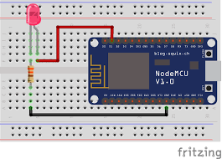

1. Connect the push button to esp8266

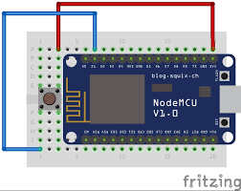

1. Connect the buzzer to esp8266

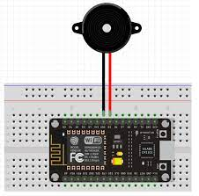

1. Connect the ultrasonic sensors to esp8266

